BUILDING COMMUNITY RESILIENCY
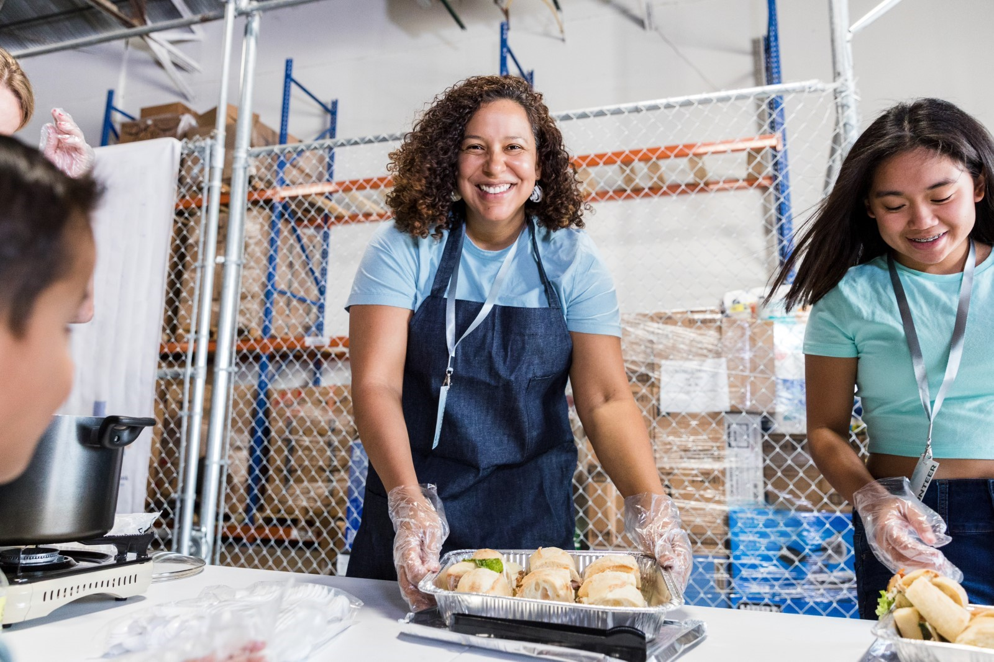
When you give to United Way, you help fortify our communities to preserve our sustainability.
United Way helps families navigate difficult times. Because of United Way’s support, four households displaced by a fire were provided immediate resources: temporary housing, hygiene kits, toys, clothing, medication, mental health support, and financial assistance. After a few weeks, all four households secured apartments and financial assistance to support their long-term housing needs.
Your support addresses the communities’ urgent needs of today for a better tomorrow. Individuals and communities will have access to disaster relief and recovery, emergency preparedness, crisis hotline and support, and environmental stewardship and sustainability.
Programs and work performed within this impact area aims to address gaps in access, opportunities, quality, and resources related to helping to meet residents with access to immediate needs, including food, housing, and water, help community residents rebuild and heal, address environmental challenges that are disrupting communities’ ways of life, and more.
Strategies that aid the effectiveness of this impact area include:
- Support short term disaster relief (e.g., emergency food, housing, and utilities/rent assistance)
- Support long-term disaster recovery work (e.g., long-term housing, rebuilding infrastructure, mental health needs)
- Address environmental sustainability (e.g., air quality, clean water, sustainable land use)
- Support efforts to mitigate impacts of disasters
- Apply an environmental justice/equity approach to disaster and environmental work
- Advocate for state/local policy change (either individually or as part of broader coalitions)
Help create possibilities for our communities today.

