UNITED WAY OF GREATER ROCHESTER AND THE FINGER LAKES: IMAGINE WHAT’S POSSIBLE
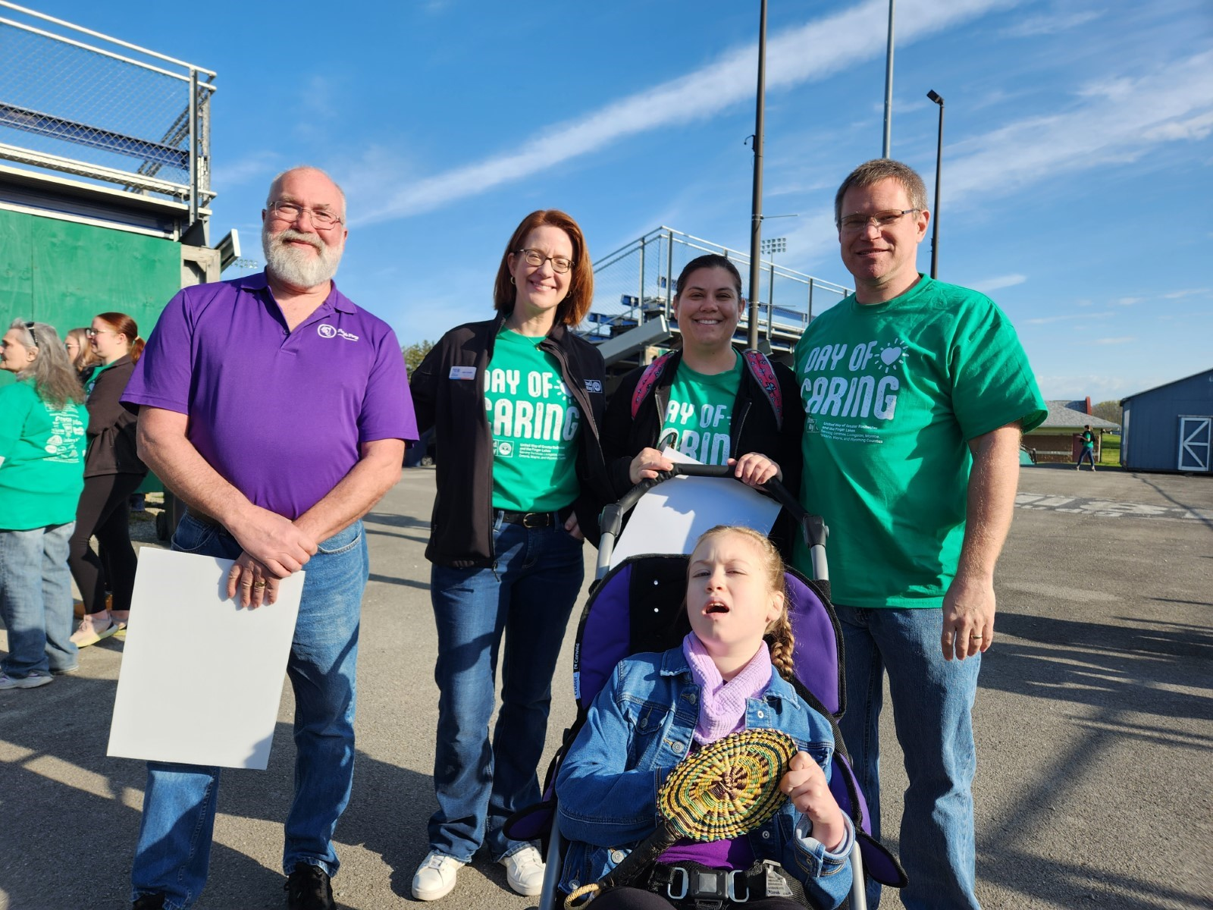
Imagine what’s possible if every individual had the necessary resources to thrive. United, it’s more than possible.
United Way of Greater Rochester and the Finger Lakes’ mission is to mobilize the goodwill and resources of our community so that everyone can thrive. United Way encompasses 5,144 square miles of rural, suburban, and urban neighborhoods, and brings together more than 50,000 donors, 13,000 volunteers, 800 workplaces, and hundreds of nonprofit partners to address the region’s biggest human services challenges.
United Way serves Genesee, Livingston, Monroe, Ontario, Wayne, and Wyoming counties. They are making progress together as a six-county region, proving that the smartest way to create a thriving community is the “united way”.
To see a more in-depth look at the impact we are making across the region, view our regional map.
Together, we can bridge the difference between what we imagine and what we impact.
Help create possibilities in your community today.

