MAKE WAY FOR GOOD

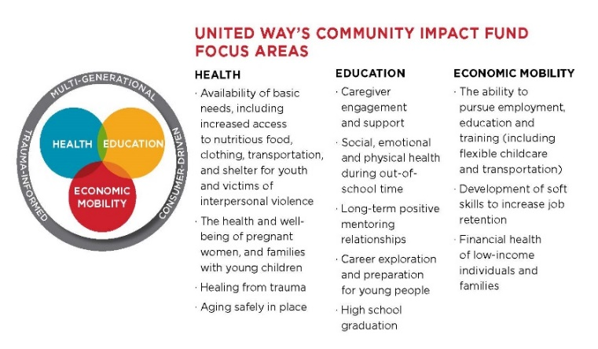
Thank you to everyone who has supported the United Way campaign in the past through payroll deduction, special events, and more. As our region continues to recover from the damage caused by the COVID-19 pandemic, many people are facing even greater hardships than they were last year. When you support United Way’s Community Impact Fund, you’re supporting thousands in our region who are still recovering from crisis. United Way’s Community Impact Fund focuses on the three core building blocks of a strong community: Health, Education and Economic Mobility.
Each new or increased donation to the Community Impact Fund will be matched, dollar-for-dollar up to $500,000, thanks to the Canandaigua National Bank & Trust 6-County Challenge. We hope we can count on you again this year to make a long-lasting impact. Donate to United Way today.
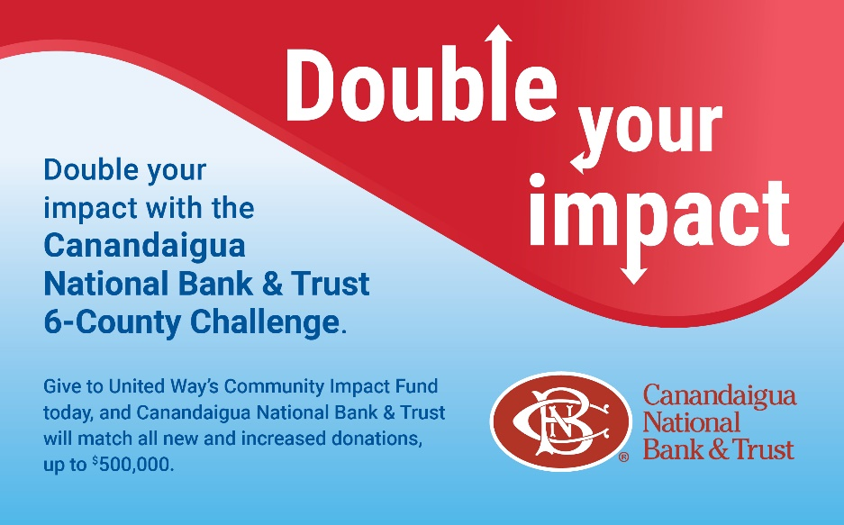

CREATING IMPACT AT EVERY LEVEL
The (COMPANY NAME) annual United Way Campaign supports the Greater Rochester area by providing health services, educational support, and economic mobility to our most vulnerable populations. Every gift at every level helps people throughout the year:

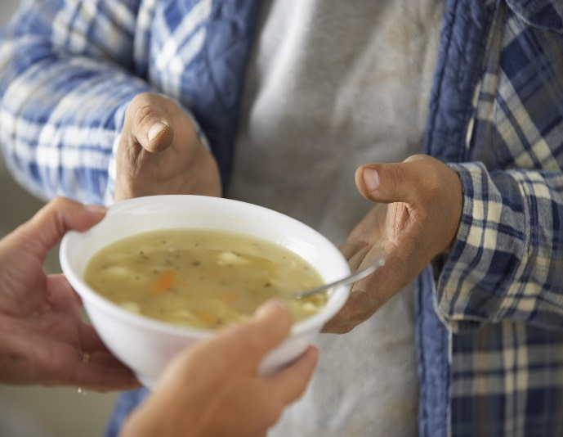
- $1 a week provides two in-home, evidence-based visits to address and overcome maternal depression, helping to create a more positive, nurturing environment for their babies.
- $2 a week helps provide a local child one week of after-school learning, including science projects, book clubs, healthy meals and snacks, and fitness activities
- $5 a week helps provide 40 meals delivered right to the doors of local older adults and people with disabilities
- $10 a week helps provide four months of mentoring for local pre-teens and teenagers to support academic excellence, positive relationships, and success later in life
- $20 a week helps give 3,000 meals to individuals and families who don’t have enough to eat at home.

Join us in supporting a brighter future for individuals and families in our community. Give to United Way today.

FOSTERing LEARNING: THE COMMUNITY IMPACT FUND AT WORK

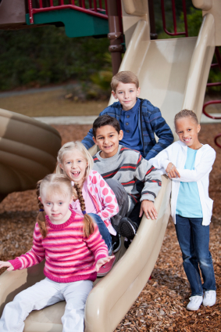
Filling children’s out-of-school time with learning and enrichment is key to helping them achieve developmental milestones. United Way of Greater Rochester and the Finger Lakes supports programs that provide children with those opportunities.
Starryana, an RCSD student, had been struggling academically. She had a passion for dance, and was enrolled in dance lessons at The Center for Youth’s After School Program, funded by United Way. When she realized that her opportunity to continue participating in dance at the After-School Program was contingent upon her progress reports at school, her academic performance began to dramatically improve.
When you invest in United Way’s Community Impact Fund, you help students like Starryana succeed academically, build confidence, cultivate leadership skills, remain physically fit, and have social interaction and development. Thank you for your support!

HELPING STUDENTS THRIVE
Janae had been attending the Horizons at Warner program, funded by United Way, since 2011. In spring of 2021, during her senior year of high school, she applied to the program for a job. She said things had gotten really hard at home, and her mother would send her two younger siblings to the program if she could work there as well. She was hired and worked through the summer, while her siblings attended the program.
It was not until she shared her college essay, program workers realized that Janae’s job at Horizons had been so much more than a job. In her essay, she shared her youngest sibling had been diagnosed with autism and her mother had been suffering with mental health issues. That, coupled with the stress of virtual learning due to the pandemic, made her and her siblings depressed. She says being able to return to Horizons made her siblings happy, gave her mom time to rest during the day, and her income helped relieve stress.
Through the program, she was also able to connect with resources to help her better understand her sibling’s autism diagnosis. Janae now hopes to study pediatric psychology in college. When you give to United Way’s Community Impact Fund, you make a difference in the lives of students like Janae and their family. Give to United Way today.

AN OPPORTUNITY TO NETWORK WHILE MAKING AN IMPACT
Thousands of local people make an annual investment of $1,000 or more ($500 for those 40 years and under) into our community with United Way. United Way's Leaders United members are the most generous, community-minded, and influential individuals throughout the Greater Rochester and Finger Lakes region. Members get to participate in several annual events, networking, and volunteering opportunities. Leaders United members may also choose to join one or more of the following networks:
- African American Leadership Society
- Circulo Latino Leadership Society
- Emerging Leaders Society
- Labor Leaders Club
- Tocqueville Society
- Women United
Give to United Way’s Community Impact Fund today and become a part of an extraordinary group of individuals committed to serving our community.

STRONGER TOGETHER
After decades of working closely together, six independent United Way organizations – from Genesee, Livingston, Monroe, Ontario, Wayne and Wyoming Counties – merged in July 2021 to create one powerful and aligned organization: United Way of Greater Rochester and the Finger Lakes.

Altogether, thanks to the generosity of committed community members like you, it raises and distribute more than $30 million annually to address the region’s biggest human services challenges.

Gifts to the United Way Community Impact Fund support a critical network of 192 partner programs providing essential services to local people. As always, dollars raised in a geographic area stay committed to that area and donors also retain the ability to direct their contributions to the causes they feel strongest about.

Thank you for joining in collective giving to build a thriving community for all.

THE IMPORTANCE OF A HEALTHY MEAL
A healthy meal is critical to a student’s well-being, yet many children are deprived of that in our region, due to food insecurity. In the Finger Lakes region, more than 156,000 residents, including more than 52,000 children, are considered food insecure.
Studies suggest food insecurity, especially in children, is linked with an increased risk of birth defects, cognitive and behavioral problems, and depression. All of these factors impact the general well-being of a community. Children from food secure households generally tend to be more successful than those from food insecure households.
Gifts to United Way’s Community Impact Fund help support local programs that help feed families. Just $20 a week can help provide 3,000 meals to families and individuals who don’t have enough to eat at home.
Please give today. Thank you!

SERVING LOCAL OLDER ADULTS
The older adult population in Rochester has grown significantly in the last decade, and so has the number of older adults living in poverty. Rochester’s older adults have the highest poverty rate of any city or county in the state, at 31 percent. The COVID-19 pandemic has intensified the hardships that older adults living in our community face, as more are calling for emotional support, housing assistance and transportation needs. United Way supports organizations such as Lifespan and Meals on Wheels that serve our community’s older population. Giving just $1 a week to United Way helps a local older adult take two round-trip outings to get safely to medical appointments, grocery shopping, social events and more. Help an older adult today by giving to United Way’s Community Impact Fund.

HAVE YOU MET ALICE?
We all know ALICE. We all rely on ALICE. ALICE, an acronym for Asset Limited, Income Constrained, Employed, is a new way of defining and understanding the struggles of individuals and households that earn above the federal poverty level, but not enough to afford basic essentials.
The ALICE research investigates, on a local level, both household incomes and costs, exposing the disparity between low-paying jobs and resources necessary to survive financially, county by county.

Based on their 2018 Report (the next report will be available this year), the number of households below the ALICE Threshold, (i.e. all households struggling to meet basic needs and thrive), within the Greater Rochester and the Finger Lakes service area averages about 37%.

United Way convenes, advocates, and innovates throughout the communities it serves and drives attention to issues faced by ALICE households, and shape solutions that promote financial stability. Learn more at UnitedForALICE.org and give to United Way today to support this important work.

FROM HELLO TO HELP, 211 IS HERE
In 2021, 120,000+ calls for assistance were made across the region. 2-1-1 Lifeline, supported by United Way, is a free, 24-hour confidential phone, chat, text service, and searchable online database that provides information, referral, and crisis/suicide prevention services in our region.
2-1-1 Lifeline calls continue to remain high compared to pre-pandemic times. Total calls for assistance for the 2021 calendar year were 120,484, higher than 2020’s total of 113,808 and over triple the 38,210 registered in 2019. Calls for housing assistance have increased substantially over recent months, primarily due to concerns relating to the expiration of the eviction and foreclosure moratoriums. Giving to United Way helps ensure people in need of immediate assistance are connected to the right resources in a timely and efficient manner. Thank you for supporting United Way.

